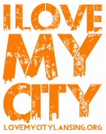
ILMC 2019 T-SHIRT ORDER FORM
All T-Shirts are priced according to size. Please make checks payable to SouthNaz
T-shirts are grey with the I LOVE MY CITY logo printed on the front.(Pictured below)
You may add either your organization logo or org. name only to the reverse side for an additional $4.00 per shirt)
Deadline: Please turn all forms in by April 24th.
After completing this form: Print and bring/mail this form with your check to South Church of the Nazarene 401 W. Holmes Rd. Lansing MI, 48910.
If you are adding a logo to the reverse of your shirts, please email the form with the logo attached.
Don’t forget to include the contact name and phone number so we can call you when your t-shirts are ready for pick-up. (Same location) – Include a printed copy of your completed form.
Instructions for form: Please click into each grey box and fill it with the requested information.
If you have trouble with this form: Please call or email web admin, Yvette Donahue, at 517 488-4547 or email her at volunteer@southnaz.org with “ILMC 2018 T-Shirt Form HELP” in the subject field.
Please Contact Tom Surdenik – ILMC Event Organizer, if you have any questions about your order.
athletesconnection@yahoo.com with “ILMC 2019 T-Shirt Question - Your Project name” – in the subject field.
Organization Name: Project Name:
Contact name: contact email: contact phone # :
Indicate the number of each type of T-Shirt needed of each option available. Plain selections will nothing on the reverse. With Org. logo selections will include your Org. logo on the reverse. With Org. name selections will include your organization name on the reverse. All shirts will have the ILMC logo on the front, regardless if you add something to the back or not.
Adult Sizes priced by size as indicated. Add $3 if you add the organization logo or name to the back:
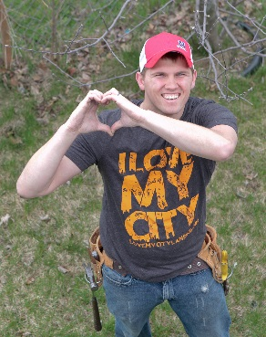
SM ($7) # plain # with Org. logo # with Org. name

MD ($7) # plain # with Org. logo # with Org. name

LG ($7) # plain # with Org. logo # with Org. name

XL ($7) # plain # with Org. logo # with Org. name

2X ($10) # plain # with Org. logo # with Org. name

3X ($11) # plain # with Org. logo # with Org. name

4X ($12) # plain # with Org. logo # with Org. name

5X ($13) # plain # with Org. logo # with Org. name

Youth Sizes are $7.00 each. Add $3 if you add the organization logo or name to the back:
SM ($7) # plain # with Org. logo # with Org. name

MD ($7) # plain # with Org. logo # with Org. name

LG ($7) # plain # with Org. logo # with Org. name

XL ($7) # plain # with Org. logo # with Org. name Order Total $

Thank-you!

